**Project 7 Coin Detection with OpenCV**

Name: Satvik Matta Period: 2 Date: March 20, 2023

Did you name your file l071.cpp (Lower case L, then 071)? Yes

Did you use OpenCV to detect coins? Yes

Did you test your code on terminal/gnu linux in c++11? Yes

Does your application create imageCircles.jpg file? Yes

Does your application create imageCoins.jpg file? Yes

Does your code display on the screen and in results.txt a summary of your results? Yes

What functions/methods from OpenCV did you use?

**imread, cvtColor, imwrite, GaussianBlur, Canny, erode, dilate, HoughCircles, cvRound, circle, center**

__________________________________________________________________________________

What functions/methods from OpenCV did you experiment with but ended up not using?

**I didn’t really experiment that much with any other methods that I remember and didn’t use**

Run your code (the same code you submit) on the 3 images I provided (easy, medium, hard) then paste here the following:

* The initial image ( the one I provided), the imageg.jpg, imagef.jpg, imageCircles.jpg , imageCoins.jpg you obtained running your code, copy paste here the content of your results.txt file your code created

1. For the easy image:

Command line including all parameter values used for this image:

./l071 -image1 -f image.jpg

Initial image:

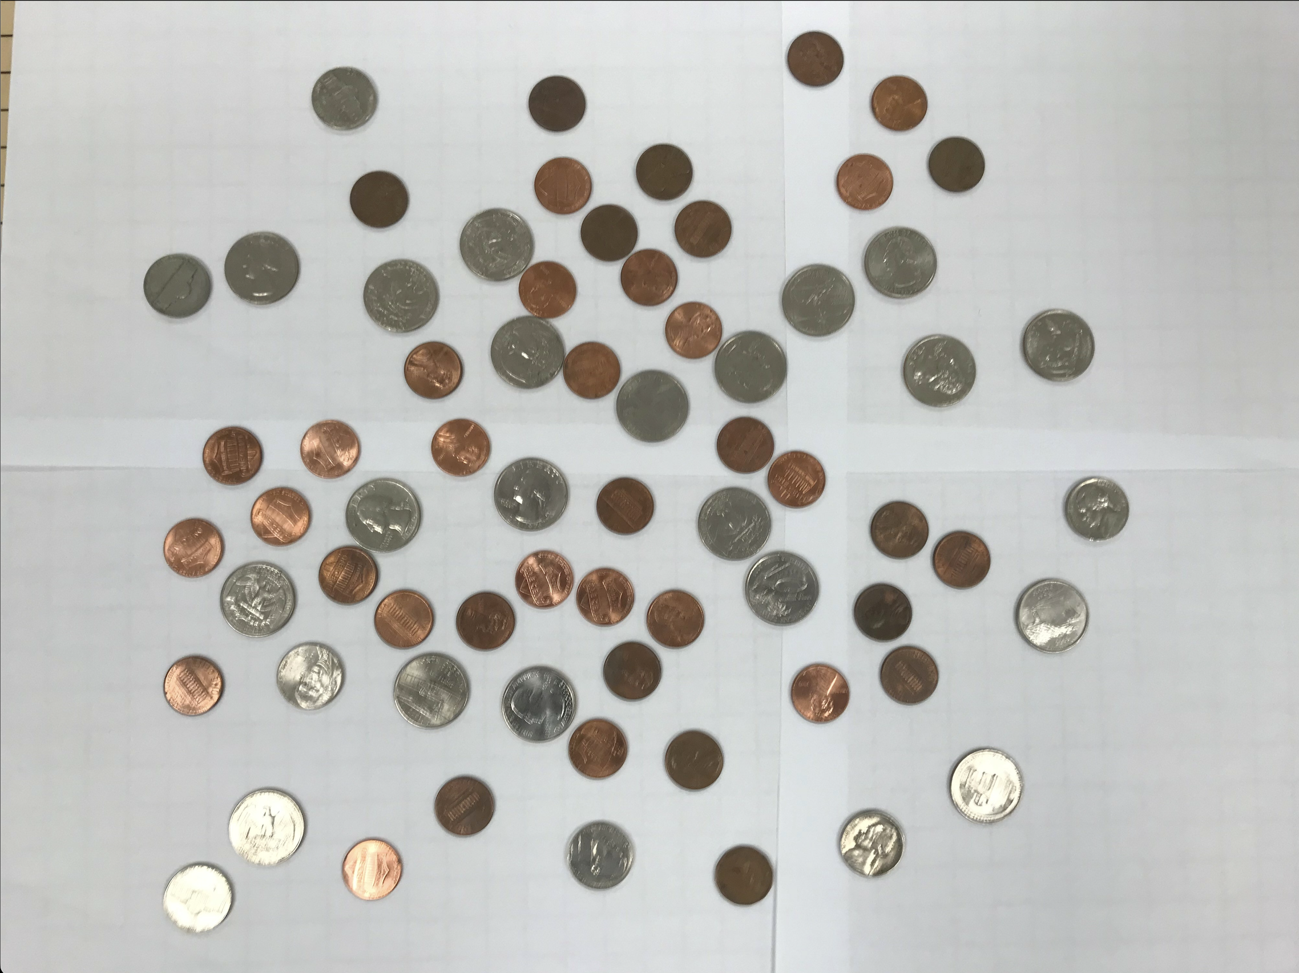

imageg.jpg:

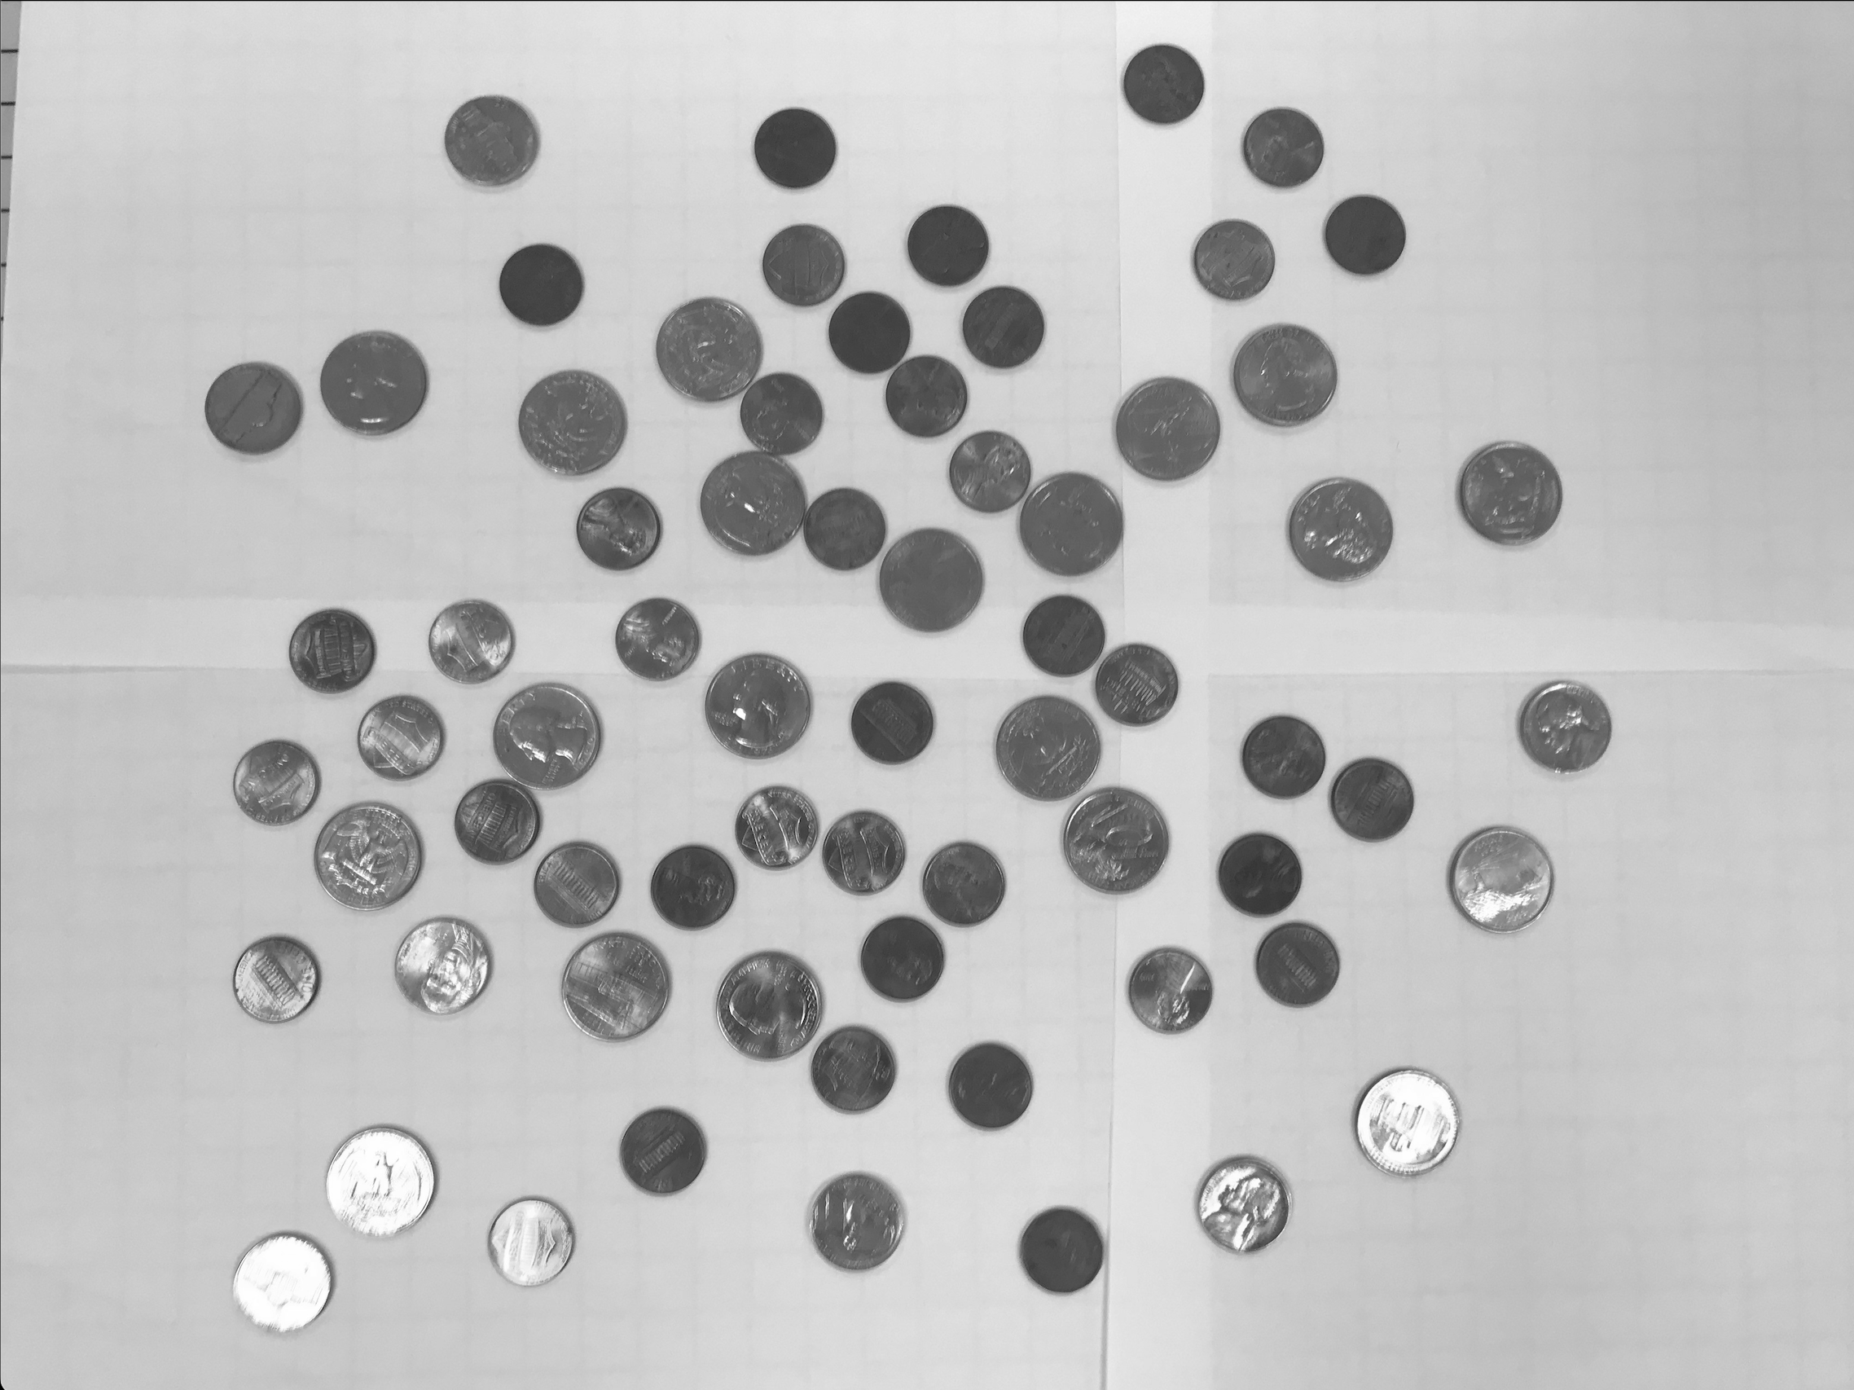

imagef.jpg

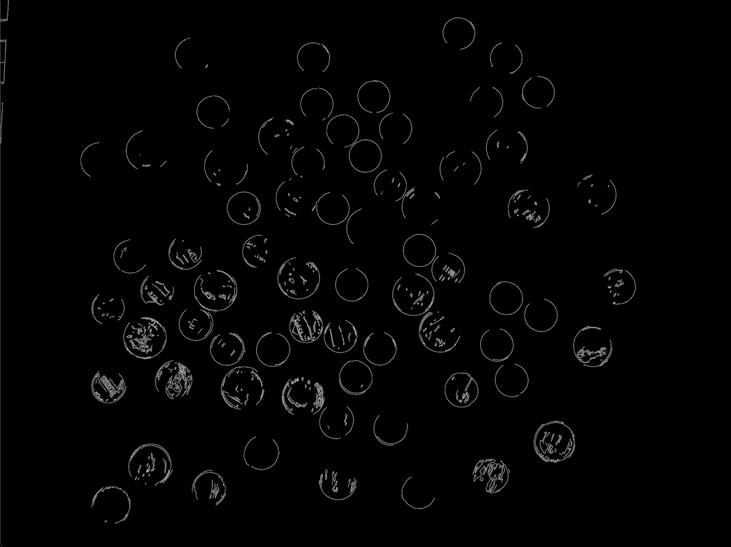

imageCircles.jpg:

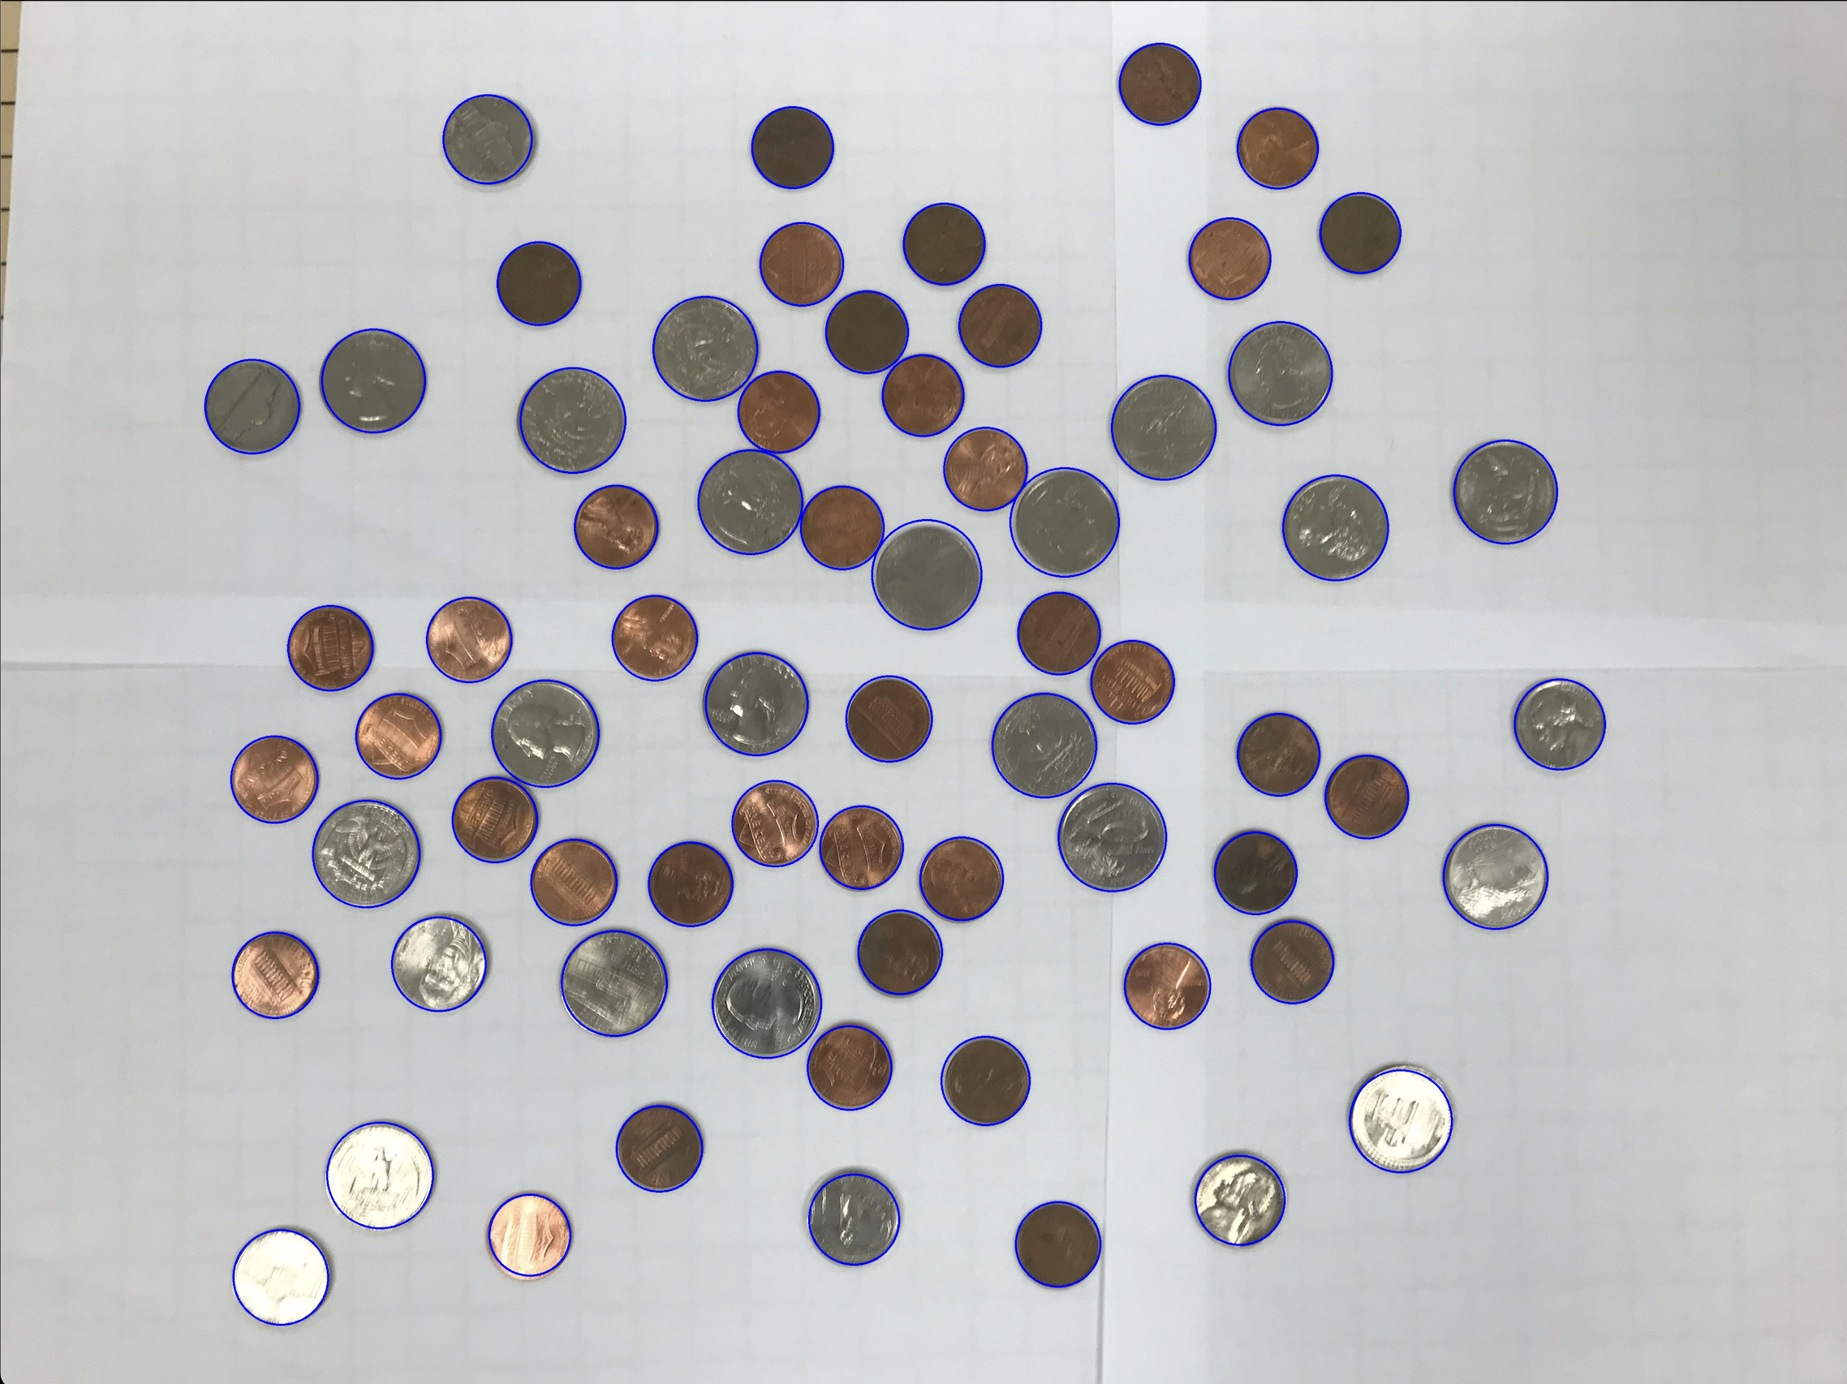

imageCoins.jpg:

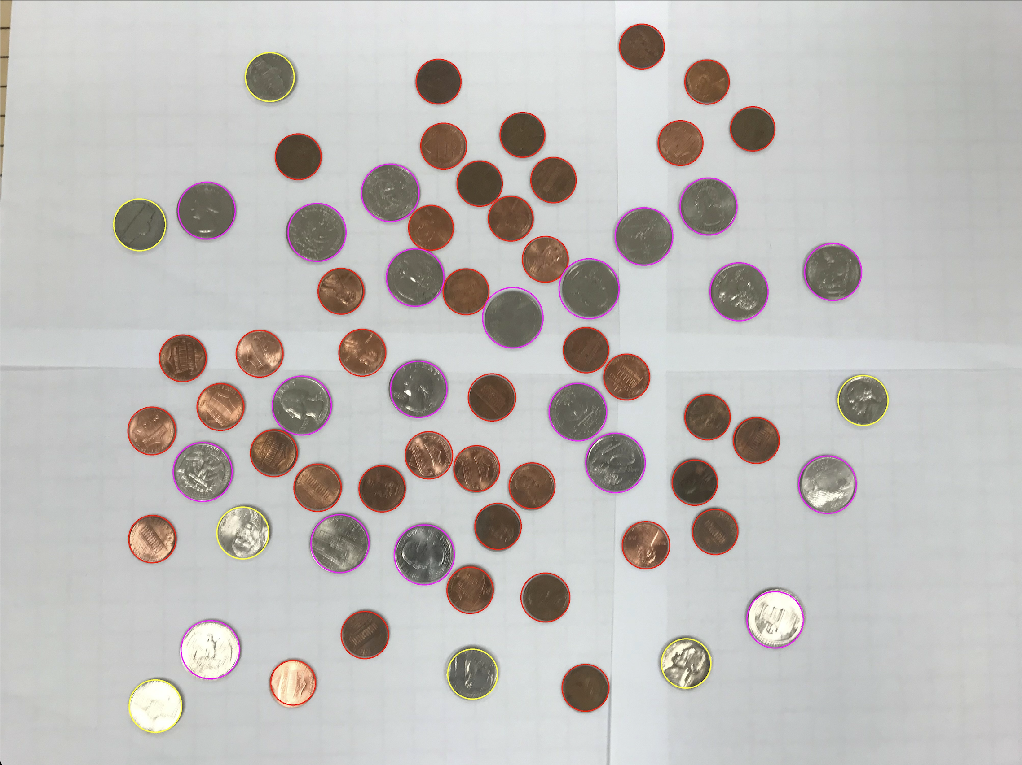

Content of results.txt:

Pennies: 41

Nickels: 7

Dimes: 0

Quarters: 20

Half Dollars0

Dollars: 0

Total value: $5.76

1. For the medium image:

Command line including all parameter values used for this image:

./l071 -image2 -f image.jpg

Initial image:

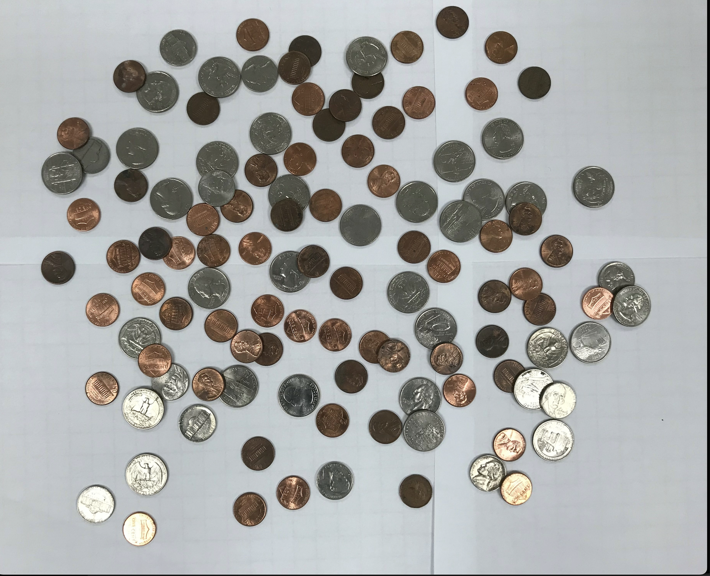

imageg.jpg:

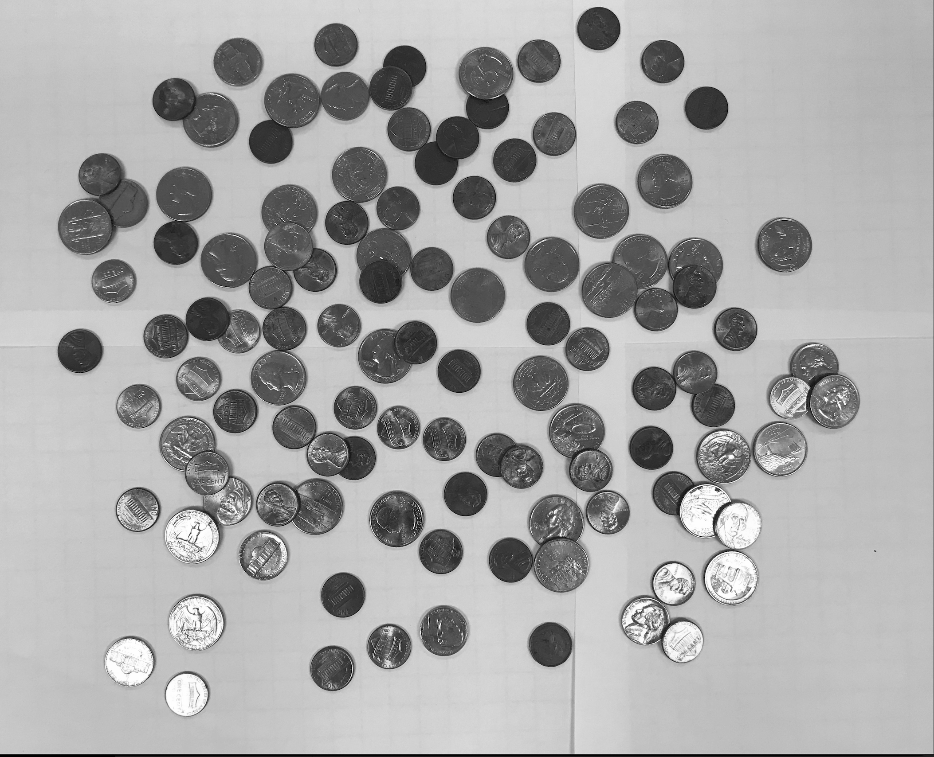

imagef.jpg

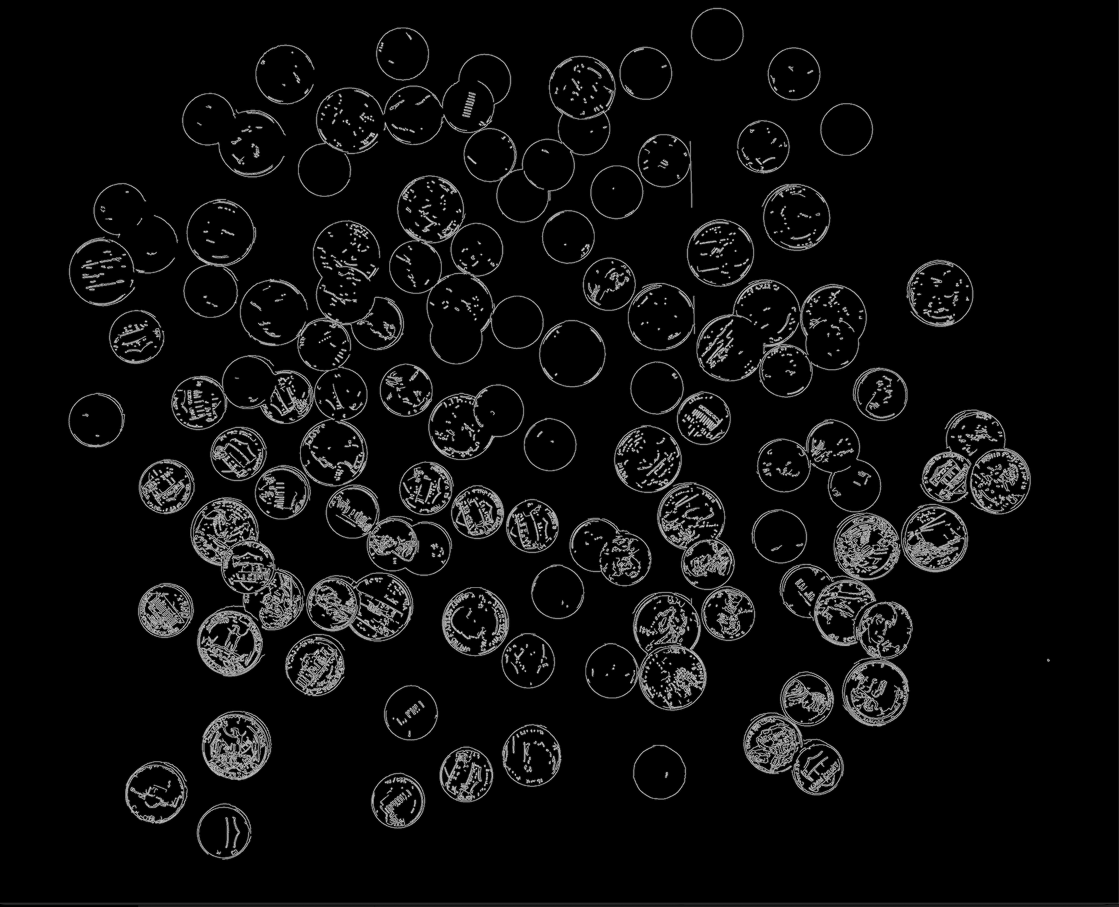

imageCircles.jpg:

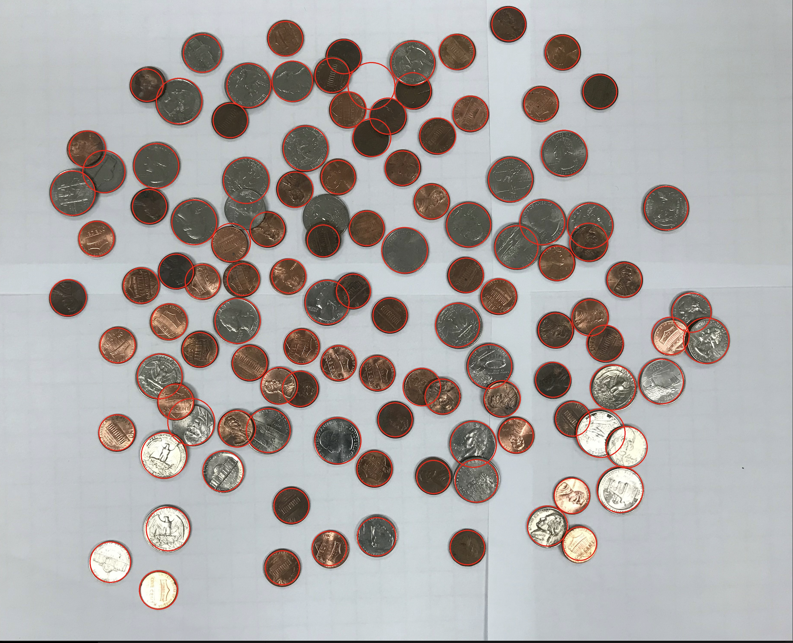

imageCoins.jpg:

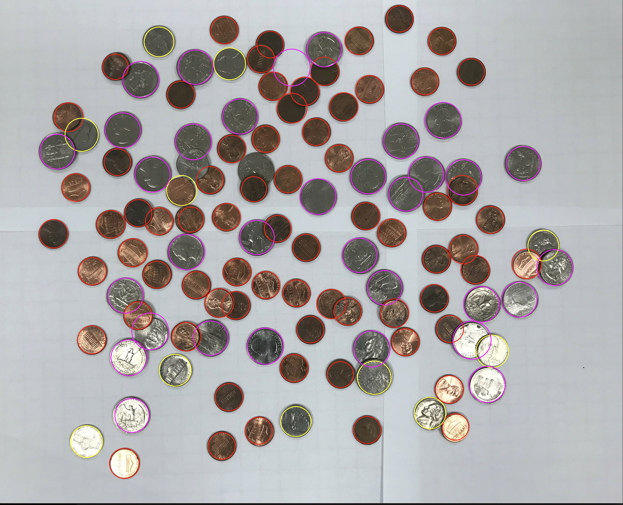

Content of results.txt:

Pennies: 71

Nickels: 11

Dimes: 0

Quarters: 33

Half Dollars0

Dollars: 0

Total value: $9.51

1. For the hard image:

Command line including all parameter values used for this image:

./l071 -image3 -f image.jpg

Initial image:

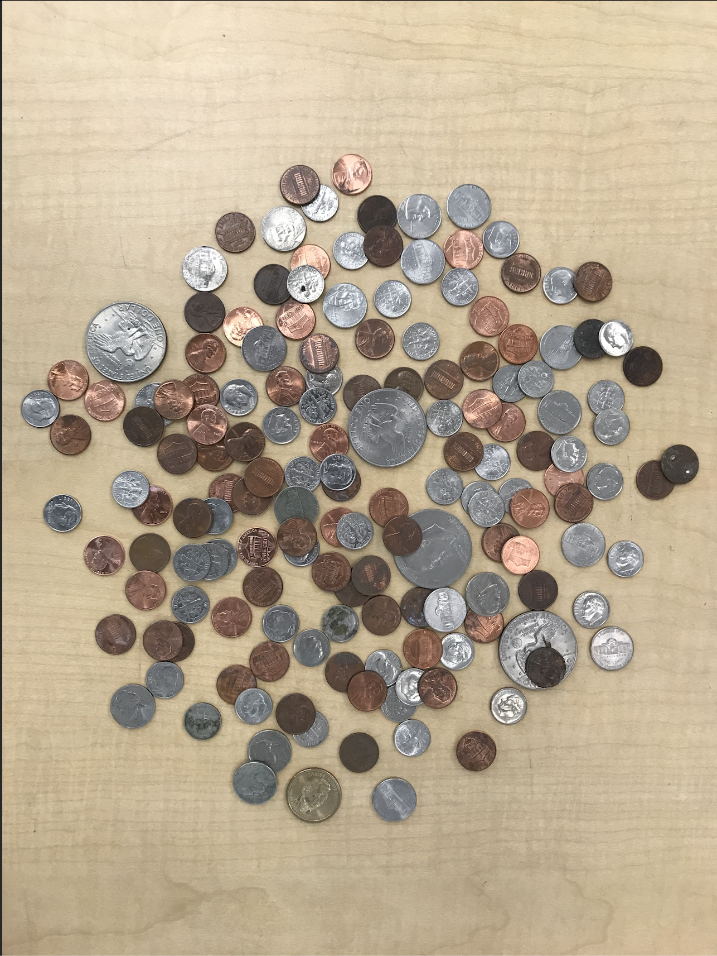

imageg.jpg:

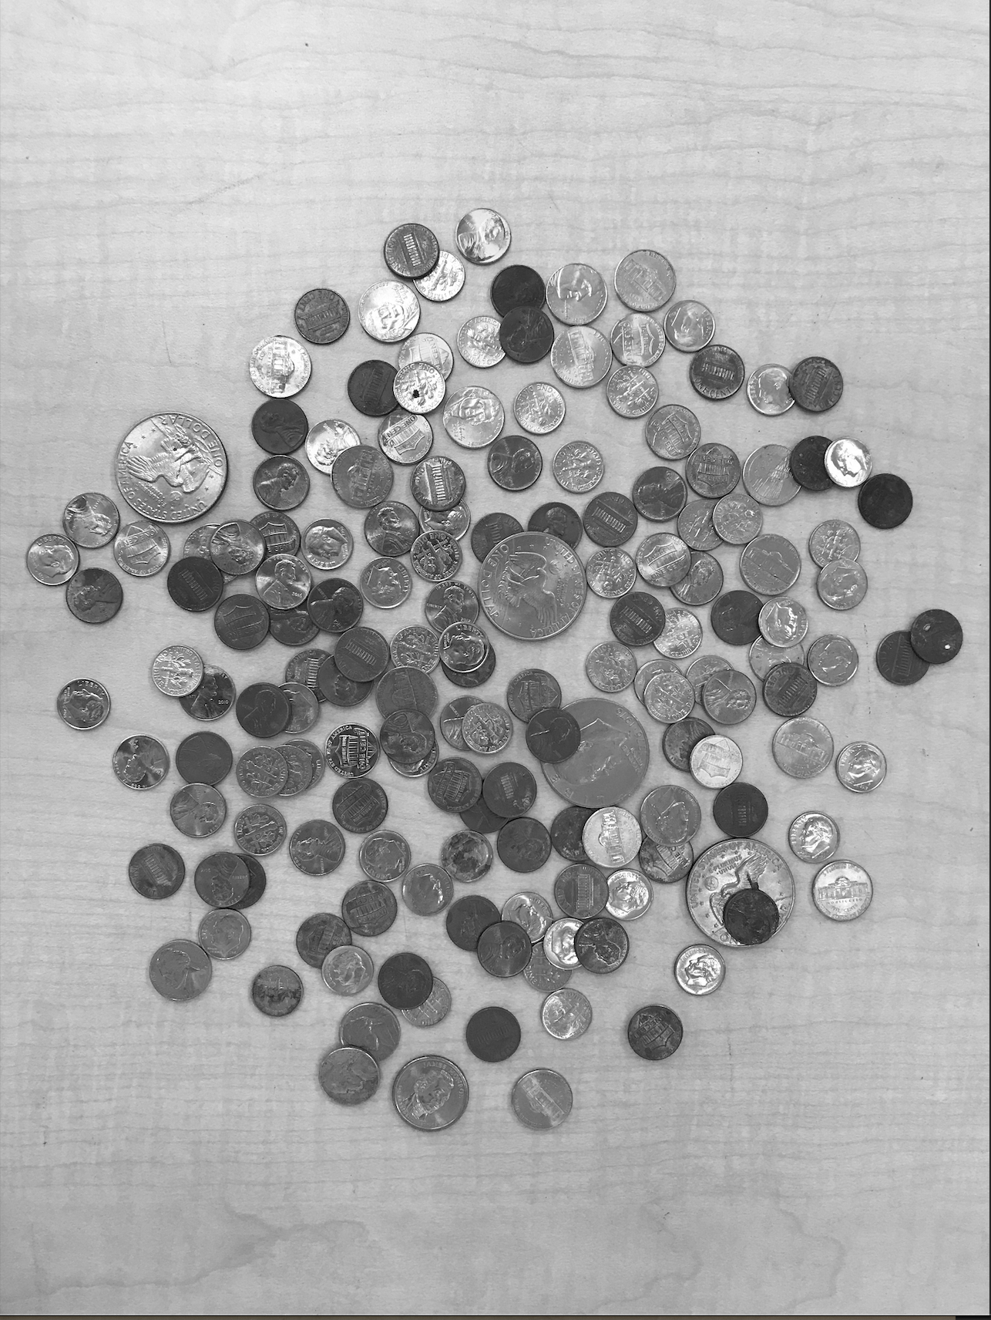

imagef.jpg

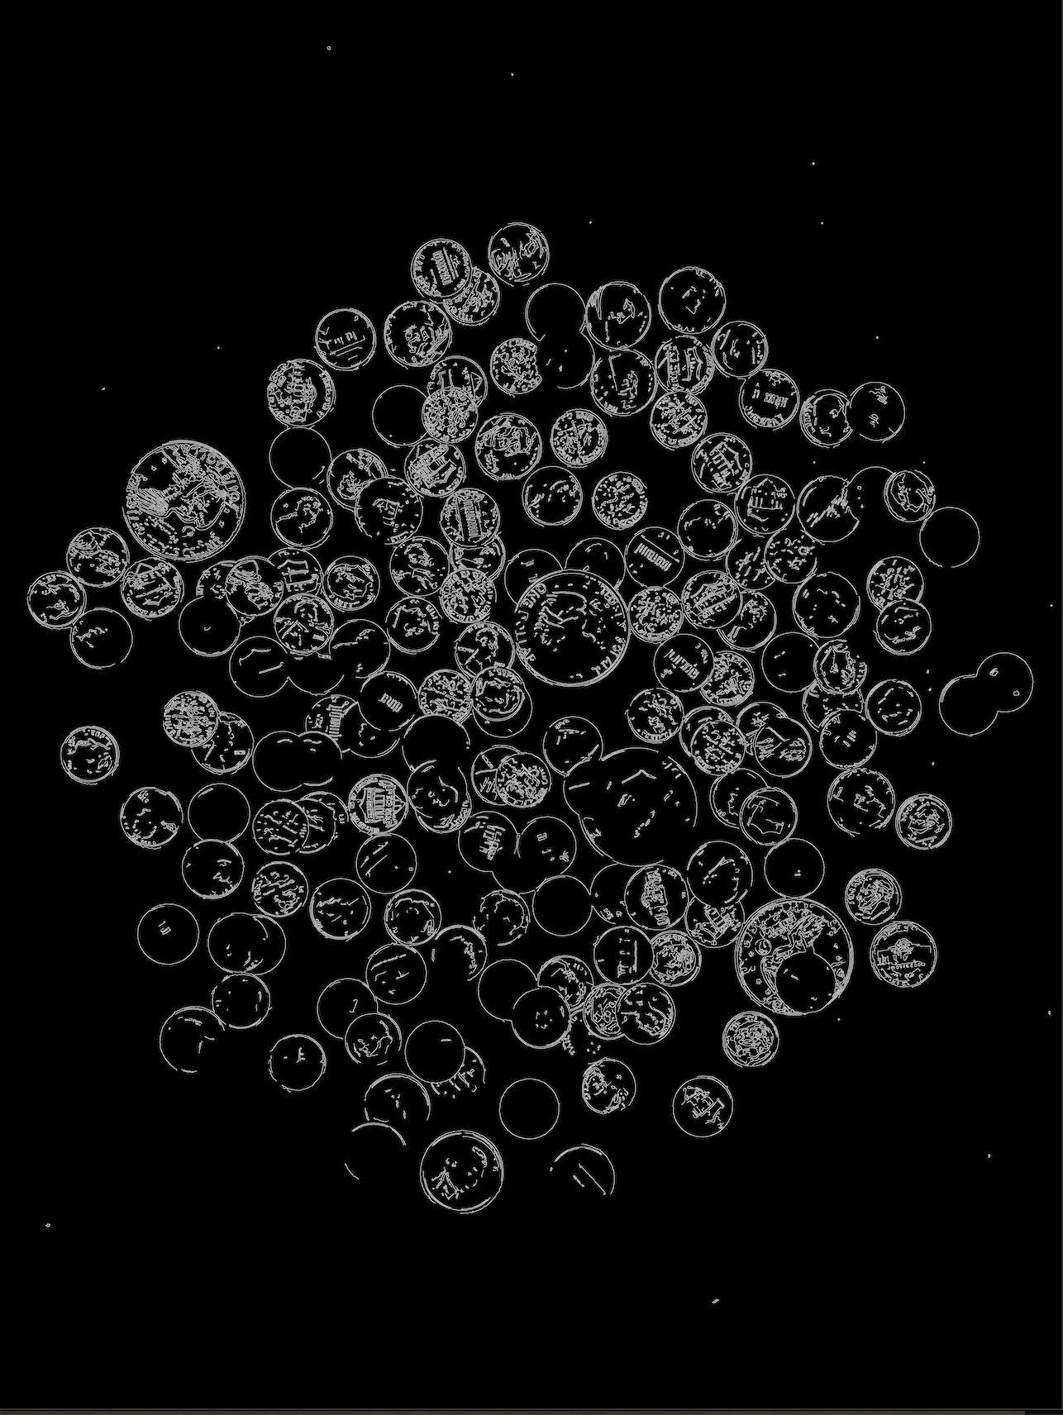

imageCircles.jpg:

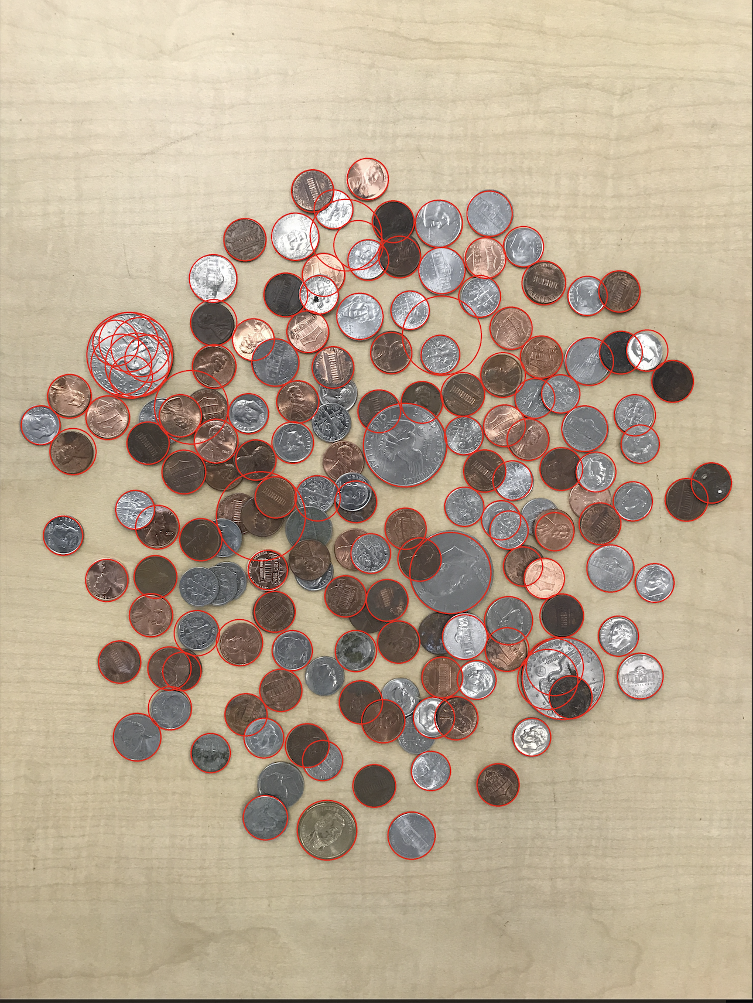

imageCoins.jpg:

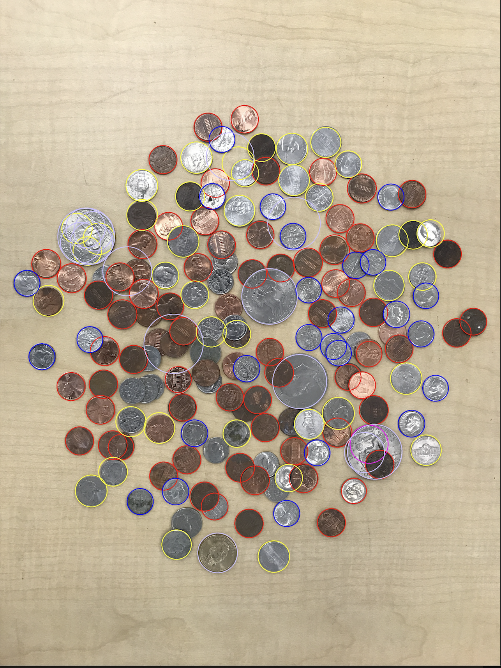

Content of results.txt:

Pennies: 68

Nickels: 39

Dimes: 26

Quarters: 1

Half Dollars0

Dollars: 14

Total value: $19.48